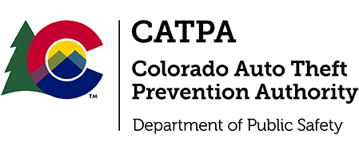

CATPA - Metropolitan Auto Theft Taskforce (C-MATT) and 17th Judicial District Executive Review of the ATM Case COCCA Indictment

Please email cale.gould@state.co.us or cdps_catpa@state.co.us for a calendar invite.

Meeting to be held at the 17th Judicial District, 1100 Judicial Center Drive Brighton Colorado, 80601

June 14th, 2024 at 2:30pm

The focus of the presentation is the positive takeaways and lessons learned from the long-term investigation of the "ATM Crew" that was conducted by C-MATT and the 17th Judicial District. The presentation will be given by C-MATT Commander Pickard and members of the 17th JD with the intent of highlighting benefits of the multijurisdictional task force approach and the success found in this case study.

